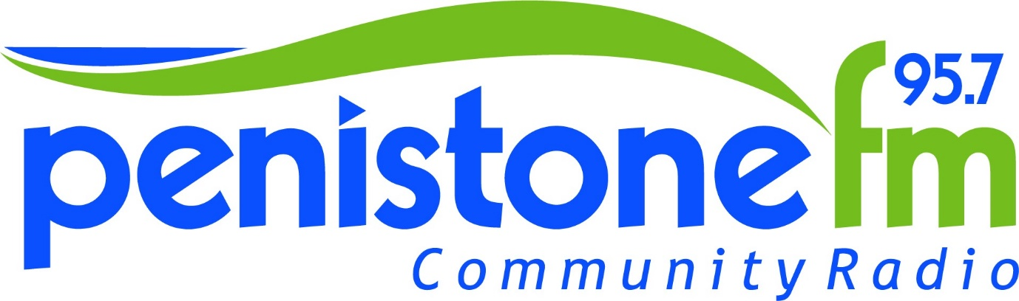
Advertising Enquiry Form
Contact Information
Name
Business Address
Postcode |  | Type of business
Home Phone |  | Mobile number
E-Mail

Is there something in particular you want to advertise about your business? How long do you see yourself advertising for? Do you have a set budget for advertising?

Thank you for completing this form.
Please return the complete form to steve.dobson@penistoneFM.co.uk or post to Penistone FM - Suite 7, Penistone 1, Regent Court, St Mary's Street, Penistone, South Yorkshire, S36 6DT
We will contact you regarding advertising as soon as possible.

Penistone FM Community Radio is committed to processing information in accordance with the General Data Protection Regulation (GDPR). All of the information collected in this form is necessary and relevant to advertising within Penistone FM Community Radio. We will treat all personal information with the upmost confidentiality and in line with current data protection legislation. The personal data collected on this form will be held securely and will only be used for administrative purposes.
You have the right to request to see a copy of the information we hold about you and to request corrections or deletions of the information that is no longer required.
I confirm that the information provided is correct and true to my knowledge and understanding.
SIGNED | PRINT | DATE

