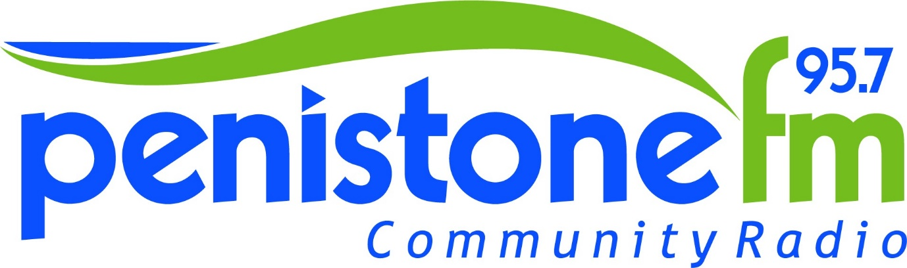
NCFE Award in Radio Form
Contact Information
Name
Address
Postcode |  | Date of Birth
Home Phone |  | Mobile
E-Mail

Emergency Contact
Name of next of kin
Number of next of kin
Relation to next of kin
Do you have any allergies/illnesses/disabilities/conditions Penistone FM would need to be made aware of?

Why do you want volunteer for Penistone FM?
Do you have any previous experience volunteering? Have you ever had any radio or tv experience? What do you hope to gain from Penistone FM?
What radio stations do you listen to regularly?
Any particular shows? Why?

What would you bring to Penistone FM?
What involvement would you like within the station? How much time can you commit? What are your interests and passions?
What qualifications do you have? Include GCSEs and any professional qualifications.

Thank you for completing the expression of interest form.
Please return the complete form to Martin.Sugden@PenistoneFM.co.uk or post to Penistone FM - Suite 7, Penistone 1, Regent Court, St Mary's Street, Penistone, South Yorkshire, S36 6DT
We will contact you regarding a possible training available as soon as the next sessions are available, if successful.

Penistone FM Community Radio is committed to processing information in accordance with the General Data Protection Regulation (GDPR). All of the information collected in this form is necessary and relevant to the position of a volunteer within Penistone FM Community Radio. We will treat all personal information with the upmost confidentiality and in line with current data protection legislation. The personal data collected on this form will be held securely and will only be used for administrative purposes.
You have the right to request to see a copy of the information we hold about you and to request corrections or deletions of the information that is no longer required.
I confirm that the information provided is correct and true to my knowledge and understanding.
SIGNED | PRINT | DATE

